Contents
1. INTRODUCTION AND PROJECT OVERVIEW 3
1.1 Project Description 3
1.3 Repository Structure 4
1.4 DevOps Technologies Used 4
2. DEVELOPMENT ENVIRONMENT SETUP 5
2.1 Maven Configuration 5
2.2 Git Repository Structure 5
2.3 JIRA Project Setup 5
3. PATTERN CASE #1: SINGLETON — NOTIFICATIONSERVICESINGLETON 6
3.1 Case Description and Problem Statement 6
3.2 Why Singleton Pattern Solves This Problem 6
3.3 GoF Participants 7
3.4 UML Class Diagram Description 7
3.5 Implementation Summary 8
3.6 Build and Run Evidence 9
4. PATTERN CASE #2: SINGLETON — PATIENTREGISTRYSINGLETON 9
4.1 Case Description and Problem Statement 9
4.2 Why Singleton Pattern Solves This Problem 9
4.3 GoF Participants 9
4.4 UML Class Diagram Description 10
4.5 Implementation Summary 10
4.6 Build and Run Evidence 11
5. PATTERN CASE #3: FACTORY METHOD — APPOINTMENTFACTORY 11
5.1 Case Description and Problem Statement 11
5.2 Why Factory Method Pattern Solves This Problem 11
5.3 GoF Participants 12
5.4 UML Class Diagram Description 12
5.5 Implementation Summary 12
5.6 Build and Run Evidence 13
6. PATTERN CASE #4: ABSTRACT FACTORY — REPORTABSTRACTFACTORY (CASE #1) 14
6.1 Case Description and Problem Statement 14
6.2 Why Abstract Factory Pattern Solves This Problem 14
6.3 GoF Participants 14
6.4 UML Class Diagram Description 15
6.5 Implementation Summary 15
6.6 Build and Run Evidence 16
7. PATTERN CASE #5: ABSTRACT FACTORY — UICOMPONENTABSTRACTFACTORY (CASE #2) 16
7.1 Case Description and Problem Statement 16
7.2 Why Abstract Factory Pattern Solves This Problem 17
7.3 GoF Participants 17
7.4 UML Class Diagram Description 17
7.5 Implementation Summary 18
7.6 Differentiation from Case #4 18
8. BUILD AND RUN EVIDENCE 19
8.1 Maven Build Output 19
8.2 Application Run Evidence 19
9. CONCLUSION AND LESSONS LEARNED 19
9.1 Pattern Selection Summary 19
10. APPENDIX: UML DIAGRAMS 20
10.1 Singleton Patterns 20
ASSUMPTIONS MADE 20

1. INTRODUCTION AND PROJECT OVERVIEW

1.1 Project Description
This deliverable implements five creational design patterns (GoF) in the Hospital Management System (HMS):
- 2 Singleton cases: Notification service centralization and patient registry
- 1 Factory Method case: Appointment type creation with varying characteristics
- 2 Abstract Factory cases: Report generation families and UI component families

1.2 Team Structure and Responsibilities
Team Member | Role | Primary Deliverables
Adham | Team Lead / Architect | A2 Scope Freeze, A3 Implementation Rules, A4-A5 Abstract Factory UMLs + Implementation, A7 Integration, A8 Report Assembly, A9 Submission Checklist
Andrew | Developer | B1-B2 Case Proposals, B3 UMLs, B4 Implementation (Singleton Case #1), B5 Report Section
Yassin | QA / Validation | C2 Testing Plan, D1 JIRA Setup, D3 Consistency Check, D4 Final Verification, D5 QA, D6 Submission Bundle, Singleton Case #2 Implementation
Maged | Developer | M1 Case Proposal, M2 Factory Method Implementation, M3 Report Section

1.3 Repository Structure
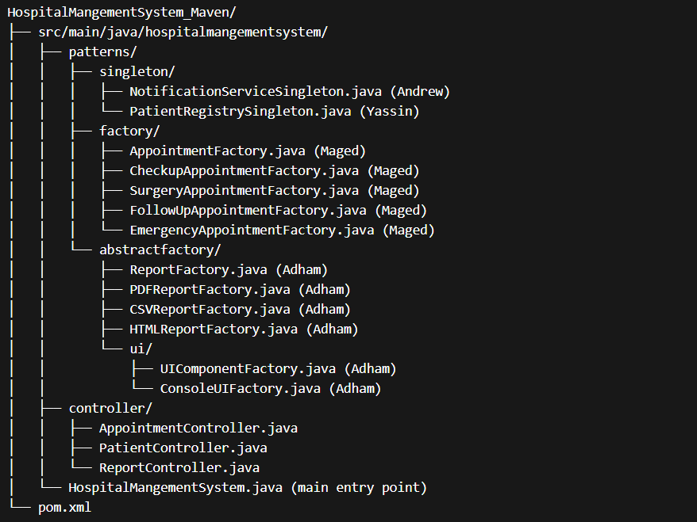

1.4 DevOps Technologies Used
- IDE: Apache NetBeans 23
- Build Tool: Apache Maven 3.9.6
- Version Control: Git with branch-per-feature strategy
- Project Management: JIRA with epics for each pattern case
- Modeling: StarUML and PlantUML for UML diagrams

2. DEVELOPMENT ENVIRONMENT SETUP

2.1 Maven Configuration
The project uses Maven for dependency management and build automation.
Key configuration in pom.xml:
- Group ID: hospitalmangementsystem
- Artifact ID: HospitalMangementSystem_Maven
- Version: 1.0-SNAPSHOT
- Java Version: 17
- Maven Compiler Plugin: 3.13.0
- Exec Maven Plugin: 3.1.0 (for running main class)

2.2 Git Repository Structure
Branch strategy following Git Flow:
- main — production-ready code
- develop — integration branch for features
- feature/andrew-singleton-factory — Andrew's patterns
- feature/yassin-singleton-case2 — Yassin's singleton case
- feature/adham-abstract-factory — Adham's abstract factory cases
- feature/maged-factory-method — Maged's factory method

2.3 JIRA Project Setup
Board: Hospital Management System - Creational Patterns
Epics
- EPIC-1: Singleton Pattern Implementation (2 cases)
- EPIC-2: Factory Method Pattern Implementation (1 case)
- EPIC-3: Abstract Factory Pattern Implementation (2 cases)
- EPIC-4: Integration and Validation
- EPIC-5: Documentation and Submission

3. PATTERN CASE #1: SINGLETON — NOTIFICATIONSERVICESINGLETON
Owner: Andrew
Package: hospitalmangementsystem.patterns.singleton

3.1 Case Description and Problem Statement
The Hospital Management System (HMS) relies on a notification service to inform patients and staff about appointment confirmations, cancellations, and reminders.
In the baseline implementation, the application's main method instantiates a SimpleNotificationService object directly with the new operator and passes it through constructor parameters to every controller.
Problems Identified
- Duplicate Instances Risk
Without centralized control, different modules may independently create their own service objects, leading to duplicated notifications and inconsistent log output.
- Configuration Fragmentation
When the notification channel evolves to SMTP email or SMS, each instance would need separate configuration.
- Constructor Wiring Complexity
Every new controller must receive the service through its constructor, coupling the wiring code tightly to the application.

3.2 Why Singleton Pattern Solves This Problem
The Singleton creational design pattern ensures that a class has exactly one instance and provides a global point of access to it (Gamma et al., 1994).
Criterion | Rationale
Single shared resource | The notification channel is inherently a shared resource; exactly one instance should coordinate all outbound messages.
Global access point | Singleton provides getInstance() — any layer can obtain the same instance without constructor threading.
Lazy initialization | Created only when first requested, saving resources if the feature is never invoked.
Thread safety | Double-checked locking with volatile ensures thread-safe initialization.
Alternatives Rejected
- Static utility class: Cannot implement interfaces, cannot be mocked for testing
- Dependency-injection framework: Would add external dependencies (violates A3 Rule 10)
- New instance per call: Wastes memory and loses accumulated state

3.3 GoF Participants
Role | Class/Interface
Singleton | NotificationServiceSingleton
Interface | NotificationService (delegate interface)
Concrete Implementation | SimpleNotificationService (wrapped by Singleton)
Client | AppointmentController

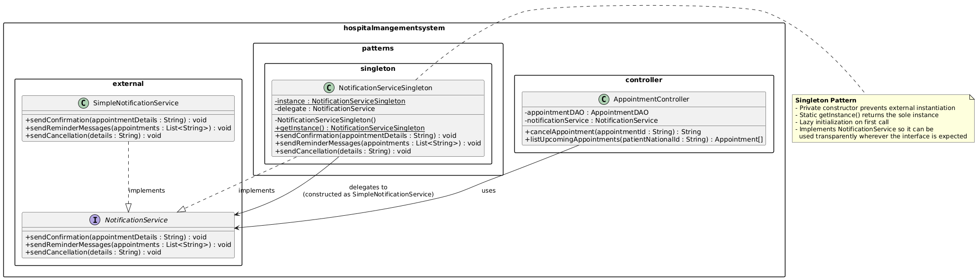

3.4 UML Class Diagram Description
(Refer to diagram: uml/andrew/NotificationServiceSingleton.png)
The class diagram shows three packages:
- external: NotificationService interface and SimpleNotificationService
- patterns.singleton: NotificationServiceSingleton with private constructor and static getInstance()
- controller: AppointmentController depends only on NotificationService interface
Key properties:
- Private constructor prevents external instantiation
- volatile static instance field for thread-safe double-checked locking
- final class to prevent subclassing
- Delegation to NotificationService implementation preserves flexibility

3.5 Implementation Summary
File: NotificationServiceSingleton.java
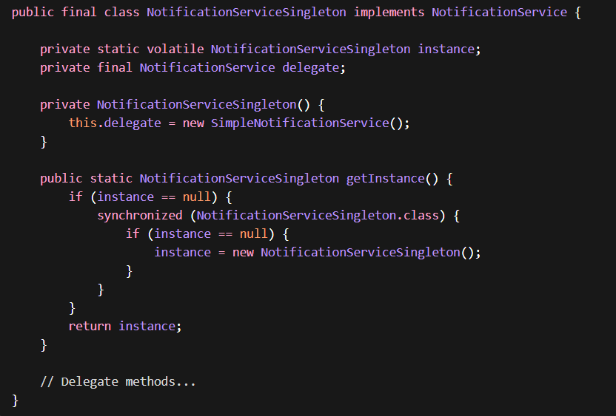
Integration (in HospitalMangementSystem.main()):

3.6 Build and Run Evidence
- Build: Maven Clean and Build completed with zero errors
- Verification: Option 2 (Cancel Appointment) produces [NotificationService] CANCELLATION: output, confirming Singleton delegates correctly to SimpleNotificationService
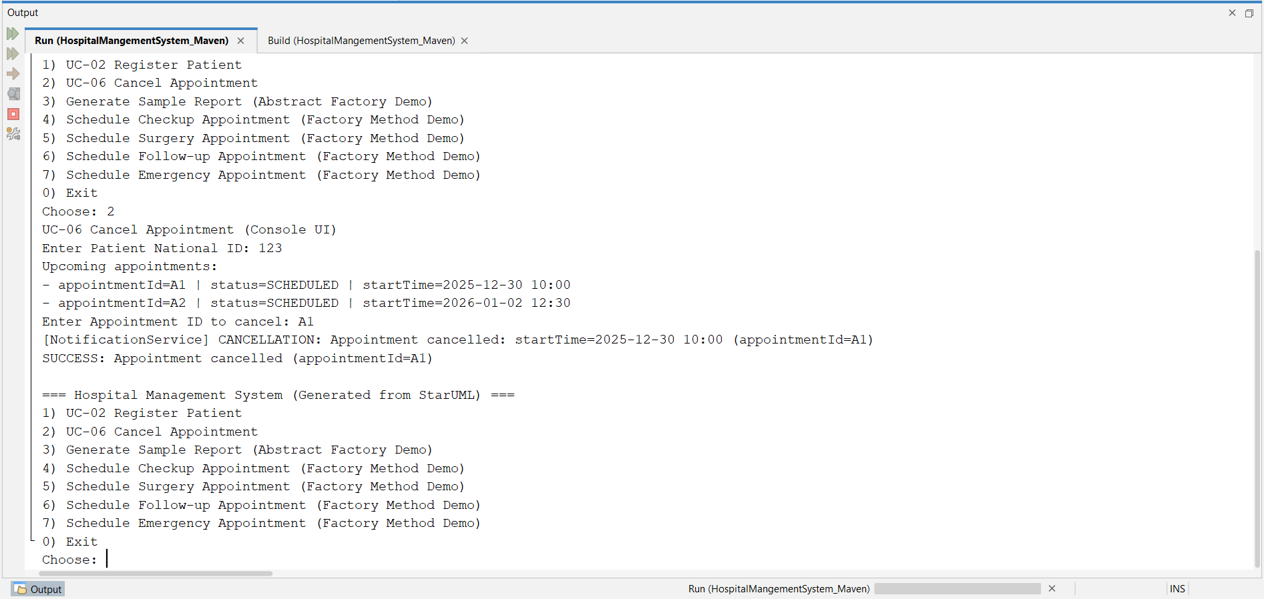

4. PATTERN CASE #2: SINGLETON — PATIENTREGISTRYSINGLETON
Owner: Yassin
Package: hospitalmangementsystem.patterns.singleton

4.1 Case Description and Problem Statement
The HMS manages patient data through a PatientDAO. Every controller receives a DAO reference through constructor injection.
Problems Identified:
- No Central Registry: Long constructor chains as each module needs patient access
- No Caching: Every lookup performs linear scan through DAO's array
- Data Consistency Risk: Multiple DAO references may lead to stale data

4.2 Why Singleton Pattern Solves This Problem
Criterion | Rationale
Single source of truth | All modules interact with exactly one registry instance
Global access | Controllers call getInstance(patientDAO) without constructor threading
Caching | Maintains HashMap<String, Patient> for O(1) lookups
Lazy initialization | Created only when first requested
Alternative Rejected: Static utility class cannot implement interfaces or be mocked.

4.3 GoF Participants
Role | Class
Singleton | PatientRegistrySingleton
DAO | PatientDAO (wrapped by Singleton)
Domain Object | Patient
Client | PatientController

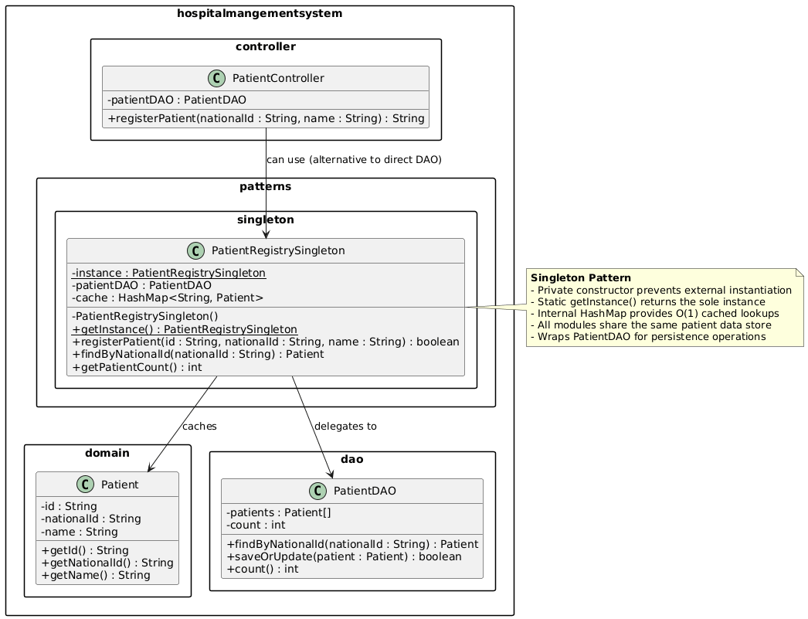

4.4 UML Class Diagram Description
(Refer to diagram: uml/andrew/PatientRegistrySingleton.png)
Shows three packages:
- domain: Patient class
- dao: PatientDAO with CRUD methods
- patterns.singleton: PatientRegistrySingleton with cache and double-checked locking

4.5 Implementation Summary
File: PatientRegistrySingleton.java
Key features:
- HashMap<String, Patient> cache for O(1) lookups
- Double-checked locking with volatile instance
- Cache-first lookup strategy with DAO fallback
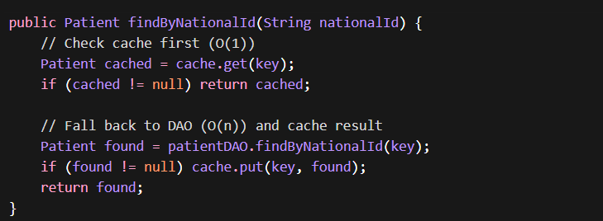

4.6 Build and Run Evidence
- Build: Zero errors with Maven
- Test Flow: Option 1 (Register Patient) successfully registers patients, cache improves lookup performance for subsequent operations
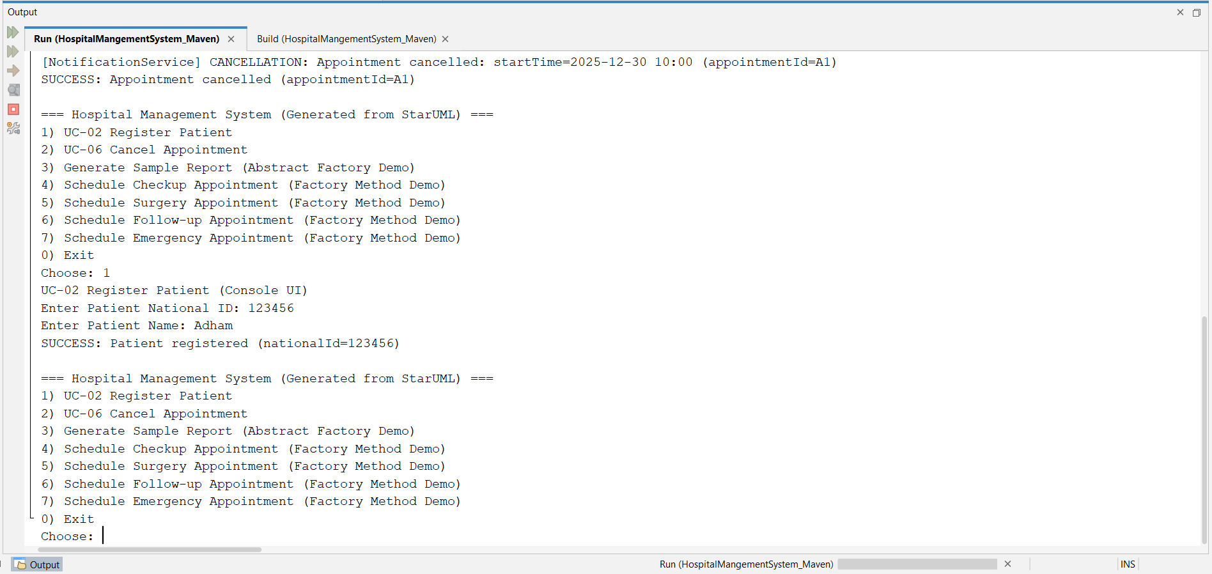

5. PATTERN CASE #3: FACTORY METHOD — APPOINTMENTFACTORY
Owner: Maged
Package: hospitalmangementsystem.patterns.factory

5.1 Case Description and Problem Statement
Appointments in HMS are created directly using new Appointment(id, startTime, status). All appointments are treated identically regardless of clinical nature.
Appointment Types and Characteristics:
- Checkup: 30-minute standard consultation
- Surgery: 2-hour procedure with pre-operative preparation
- Follow-up: 15-minute revisit linked to previous appointment
- Emergency: High priority, immediate care
Problems:
- Direct instantiation violates Open/Closed Principle
- Adding new types requires modifying multiple locations
- Creation logic scattered across codebase

5.2 Why Factory Method Pattern Solves This Problem
The Factory Method pattern defines an interface for creating an object while allowing subclasses to determine the concrete class (Gamma et al., 1994).
Criterion | Rationale
Encapsulates creation logic | Each type's validation and defaults in dedicated factory subclass
Open/Closed Principle | New types require only new factory subclass
Decouples client | Controllers call factory.createAppointment() without knowing concrete subtype
Single Responsibility | Creation logic separated from business logic
Alternative Rejected: Abstract Factory would be overkill for single product type.

5.3 GoF Participants
Role | Class
Product | Appointment (base class in domain)
Concrete Products | CheckupAppointment, SurgeryAppointment, FollowUpAppointment, EmergencyAppointment
Creator | AppointmentFactory (abstract)
Concrete Creators | CheckupAppointmentFactory, SurgeryAppointmentFactory, FollowUpAppointmentFactory, EmergencyAppointmentFactory
Client | AppointmentController

5.4 UML Class Diagram Description
(Refer to diagram: uml/maged/M3_FactoryMethod_AppointmentFactory.png)
Shows:
- domain: Appointment base class with getType() and getDurationMinutes() methods
- patterns.factory: AppointmentFactory with abstract createAppointment() and template method bookAppointment()
- Four concrete factories each creating their respective appointment type
- controller: AppointmentController uses abstract factory
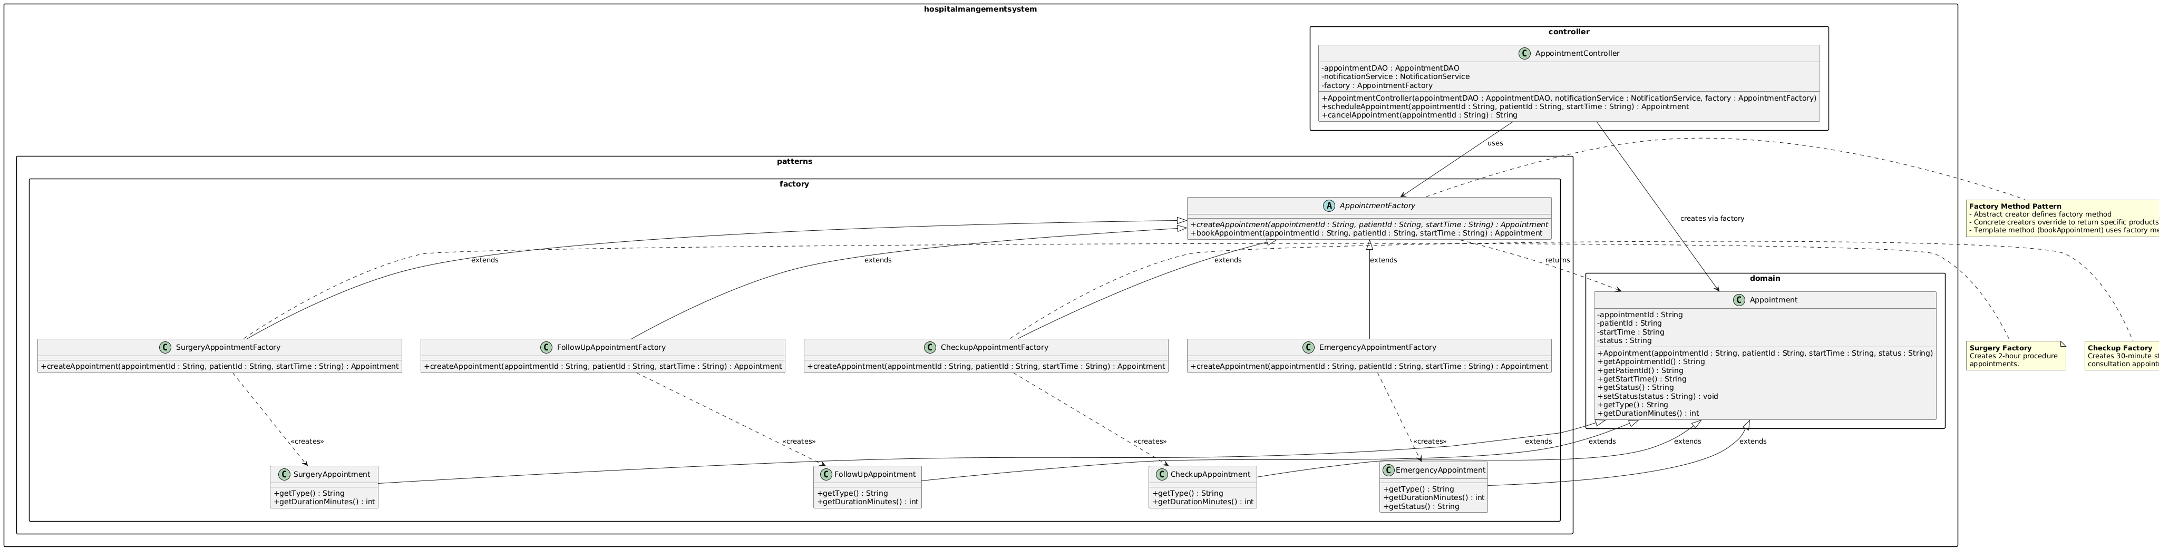

5.5 Implementation Summary
Abstract Creator (AppointmentFactory.java):
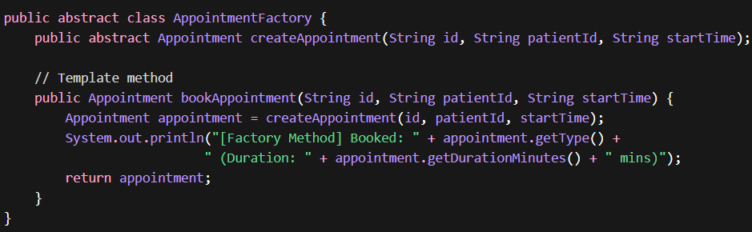
Concrete Product Example (CheckupAppointment.java):
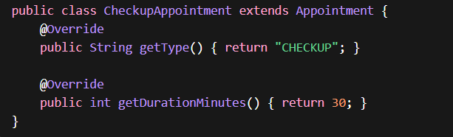

5.6 Build and Run Evidence
Menu options 4-7 demonstrate Factory Method:
- Option 4: Schedule Checkup → outputs "[Factory Method] Booked: CHECKUP (Duration: 30 mins)"
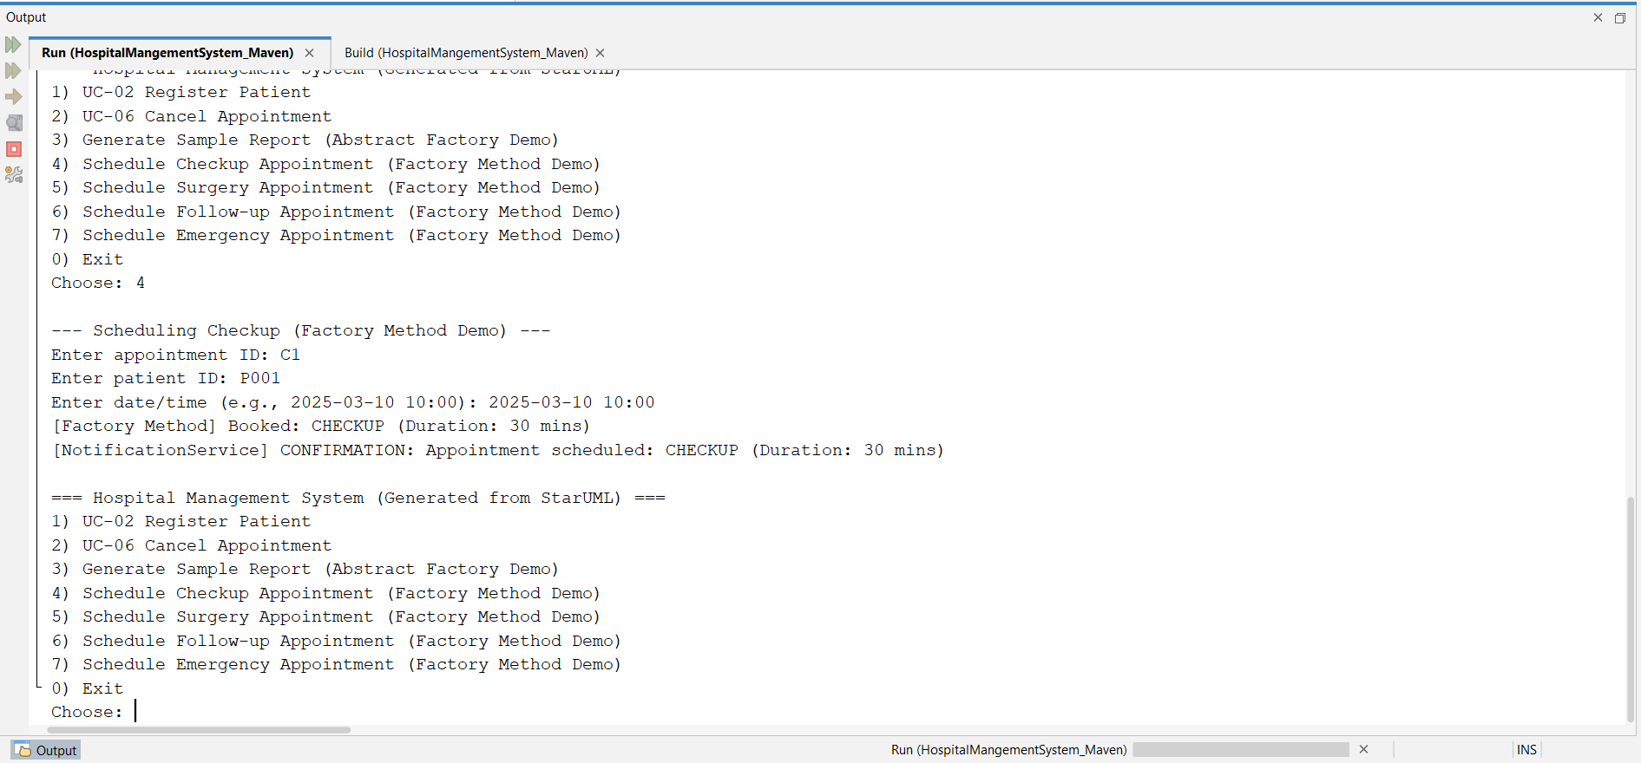
- Option 5: Schedule Surgery → outputs "[Factory Method] Booked: SURGERY (Duration: 120 mins)"
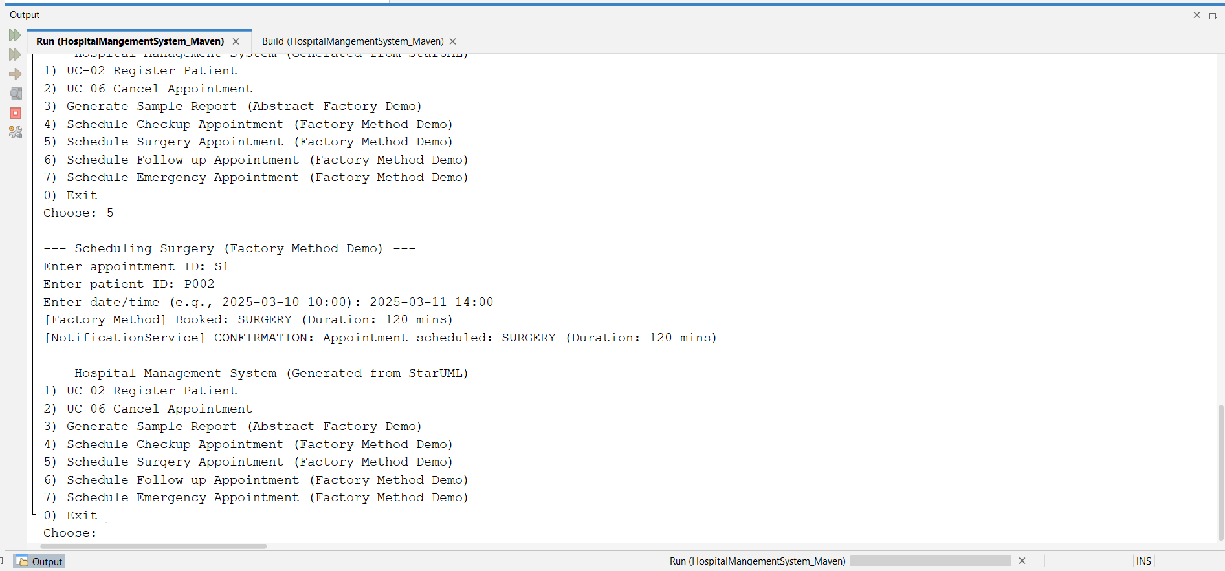
- Option 6: Schedule Follow-up → outputs "[Factory Method] Booked: FOLLOW_UP (Duration: 15 mins)"
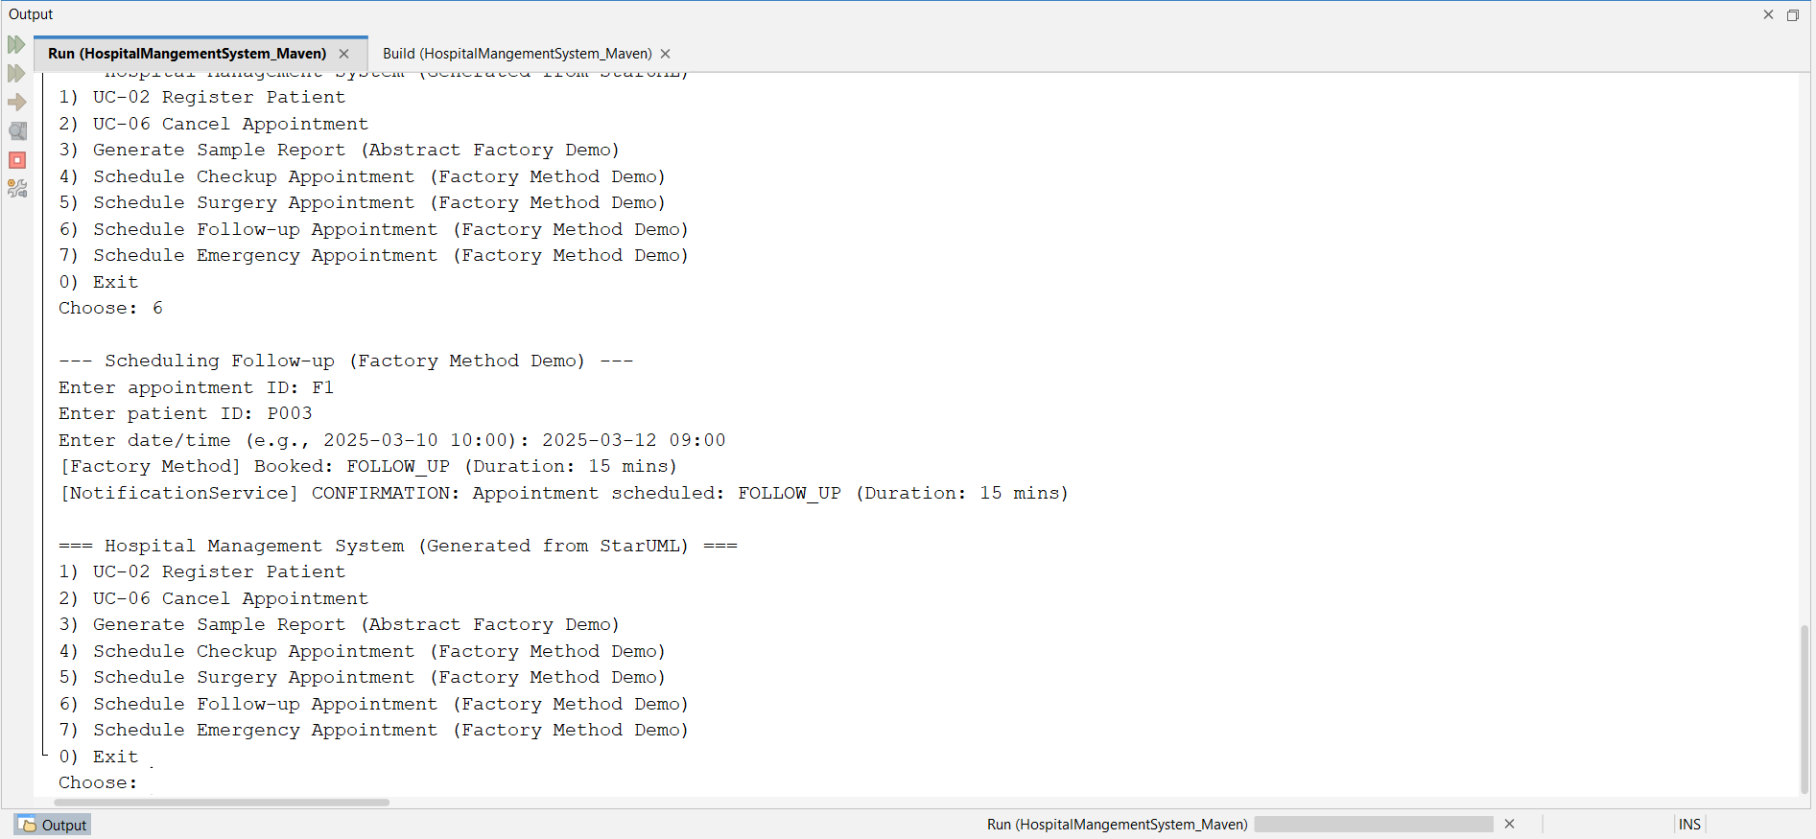
- Option 7: Schedule Emergency → outputs "[Factory Method] Booked: EMERGENCY (Duration: 60 mins)"
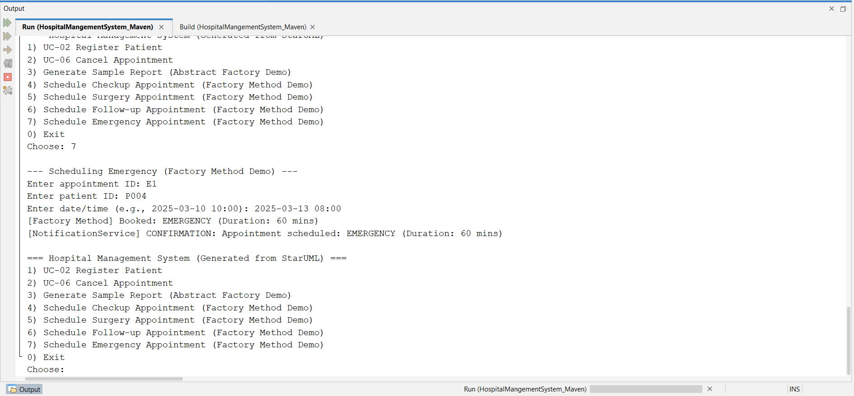

6. PATTERN CASE #4: ABSTRACT FACTORY — REPORTABSTRACTFACTORY (CASE #1)
Owner: Adham
Package: hospitalmangementsystem.patterns.abstractfactory

6.1 Case Description and Problem Statement
HMS needs to generate reports in different formats:
- Administrators: PDF for archival and email
- Analysts: CSV for Excel/Python processing
- Patients: HTML for web browsers
Problems:
- No unified creation mechanism
- Hard-coded format logic in controllers
- Risk of mixing incompatible components (PDF header with CSV footer)
- Violation of Open/Closed Principle when adding new formats

6.2 Why Abstract Factory Pattern Solves This Problem
The Abstract Factory pattern provides an interface for creating families of related objects without specifying concrete classes (Gamma et al., 1994).
Criterion | Rationale
Product family consistency | Each factory creates compatible components (PDF header + PDF footer + PDF chart)
Decoupling | Controllers depend only on abstract interfaces
Format extensibility | New formats require only new factory + products
Runtime selection | Factory selected at runtime based on configuration

6.3 GoF Participants
Role | Interface/Class
Abstract Factory | ReportFactory
Concrete Factories | PDFReportFactory, CSVReportFactory, HTMLReportFactory
Abstract Products | ReportDocument, ReportHeader, ReportFooter, ChartComponent
Concrete Products | PDFReportDocument, PDFReportHeader, etc. (3 families × 4 products = 12 classes)
Client | ReportController

6.4 UML Class Diagram Description
(Refer to diagram: uml/adham/A4_ReportAbstractFactory.png)
Shows three product families:
- PDF Family: PDFReportDocument, PDFReportHeader, PDFReportFooter, PDFChartComponent
- CSV Family: CSVReportDocument, CSVReportHeader, CSVReportFooter, CSVChartComponent
- HTML Family: HTMLReportDocument, HTMLReportHeader, HTMLReportFooter, HTMLChartComponent
Each concrete factory creates exactly one family. Dashed arrows show "creates" relationships.
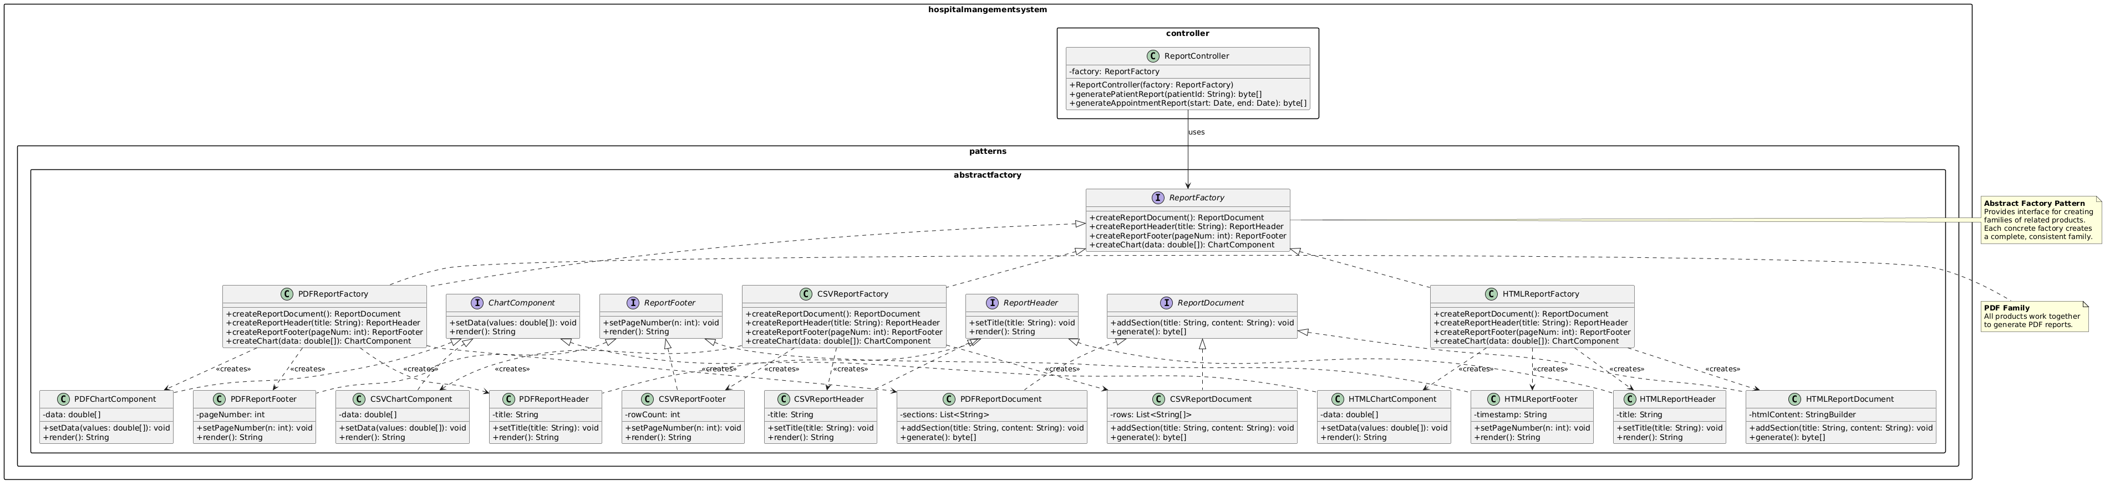

6.5 Implementation Summary
Abstract Factory Interface:
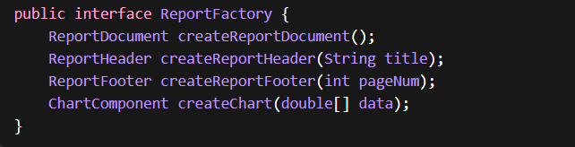
Concrete Factory (PDFReportFactory.java):
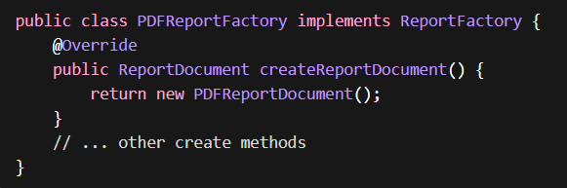
Client Usage (in HospitalMangementSystem.main()):

6.6 Build and Run Evidence
Menu option 3 demonstrates Abstract Factory:
- Generates sample PDF patient report
- Outputs "Report generated! Content-Type: application/pdf"
- Shows preview of first 200 characters
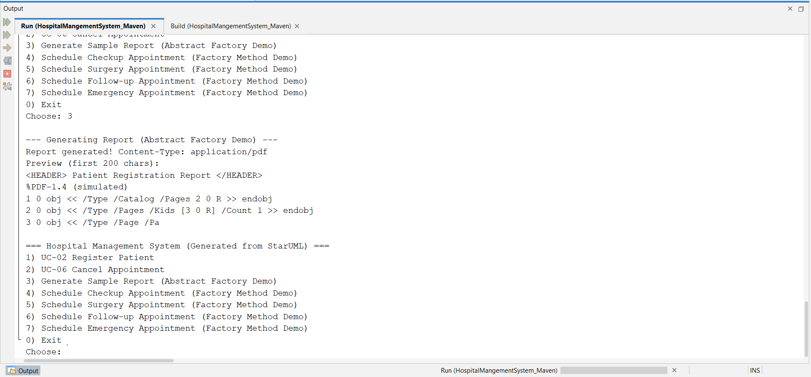

7. PATTERN CASE #5: ABSTRACT FACTORY — UICOMPONENTABSTRACTFACTORY (CASE #2)
Owner: Adham
Package: hospitalmangementsystem.patterns.abstractfactory.ui

7.1 Case Description and Problem Statement
HMS has UI components (menus, inputs, buttons) that need different presentations:
- Console: ASCII art, plain text
- Web: HTML tags, styled output
- Accessible: Screen-reader friendly with ARIA labels
Problems:
- UI logic mixed with presentation
- No way to switch themes without modifying UI code
- Accessibility requirements not systematically addressed

7.2 Why Abstract Factory Pattern Solves This Problem
Criterion | Rationale
UI family consistency | All components from one factory share the same theme
Environment portability | Same logic renders to console, web, or screen reader
No UI class modification | New themes require only new factory + products
Complete separation | UI logic separated from presentation

7.3 GoF Participants
Role | Interface/Class
Abstract Factory | UIComponentFactory
Concrete Factories | ConsoleUIFactory, WebUIFactory, AccessibleUIFactory
Abstract Products | MenuComponent, InputComponent, ButtonComponent, DividerComponent
Concrete Products | ConsoleMenu, ConsoleInput, etc.
Client | PatientUI, AppointmentUI

7.4 UML Class Diagram Description
(Refer to diagram: uml/adham/A5_UIComponentAbstractFactory.png)
Shows three UI themes:
- Console Theme: ASCII dividers, bracketed buttons
- Web Theme: HTML tags for browsers
- Accessible Theme: ARIA labels, full descriptions
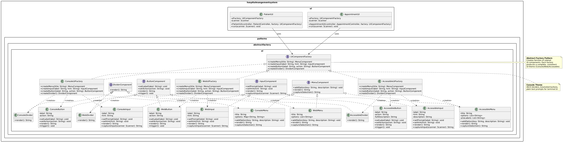

7.5 Implementation Summary
Abstract Factory Interface:
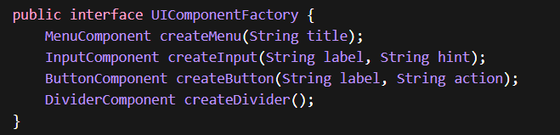
Concrete Factory (ConsoleUIFactory.java):
Nested classes implement components for console rendering.

7.6 Differentiation from Case #4
Aspect | Case #4: ReportAbstractFactory | Case #5: UIComponentAbstractFactory
Domain | Backend report generation | Frontend UI presentation
Product Types | Document, Header, Footer, Chart | Menu, Input, Button, Divider
Variation Axis | Output format (PDF/CSV/HTML) | Display environment (Console/Web/Accessible)
Purpose | Data export flexibility | UI theming and accessibility

8. BUILD AND RUN EVIDENCE

8.1 Maven Build Output
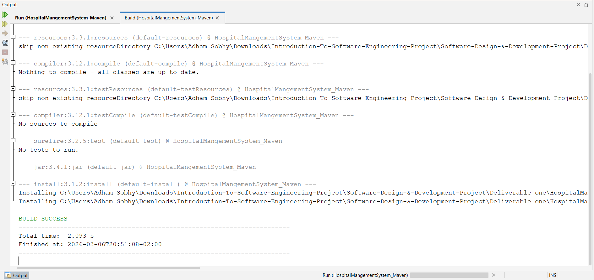

8.2 Application Run Evidence
Main Menu
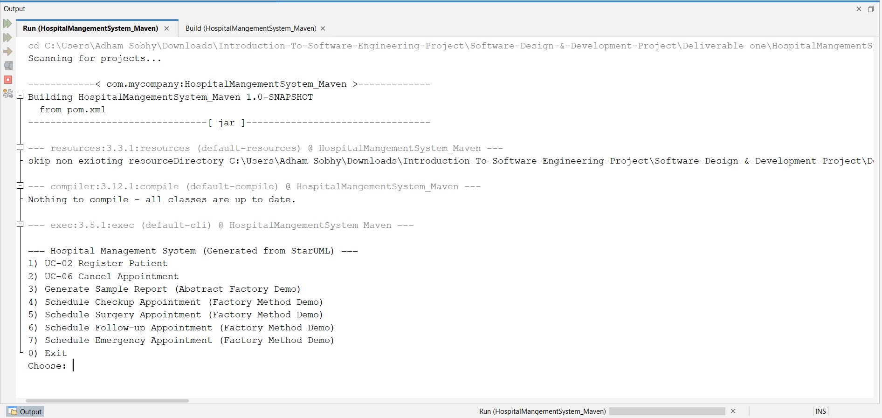

9. CONCLUSION AND LESSONS LEARNED

9.1 Pattern Selection Summary
Pattern | Cases | Primary Benefit
Singleton | 2 cases | Global access to shared resources (notification service, patient registry)
Factory Method | 1 case | Extensible appointment creation without modifying existing code
Abstract Factory | 2 cases | Consistent families of related objects (reports, UI components)

10. APPENDIX: UML DIAGRAMS

10.1 Singleton Patterns
Diagram 1 — NotificationServiceSingleton (Andrew)
File: uml/andrew/NotificationServiceSingleton.png
PlantUML: uml/andrew/NotificationServiceSingleton.mdj
Diagram 2 — PatientRegistrySingleton (Yassin)
File: uml/andrew/PatientRegistrySingleton.png
PlantUML: uml/andrew/PatientRegistrySingleton.mdj

ASSUMPTIONS MADE
- Code Generation
The HMS domain classes (Patient, Appointment, etc.) were generated from StarUML class diagram using the Java profile.
- Notification Channel
The notification service currently uses console output; future versions may extend to email/SMS without changing the Singleton pattern structure.
- Persistence
PatientDAO and AppointmentDAO use in-memory storage (arrays) for demonstration; database persistence would not affect pattern implementations.
- Thread Safety
While current implementation is single-threaded, both Singleton implementations use double-checked locking for future multi-threading safety.
- Factory Method Scope
The AppointmentFactory creates domain objects only; persistence is handled separately by the controller after creation.
- UI Abstraction
UIComponentFactory demonstrates the pattern conceptually; full UI framework integration would require additional rendering infrastructure.

